

**www.russelltaylors.co.uk**

**Electric Pressure Cooker**

**USER MANUAL**

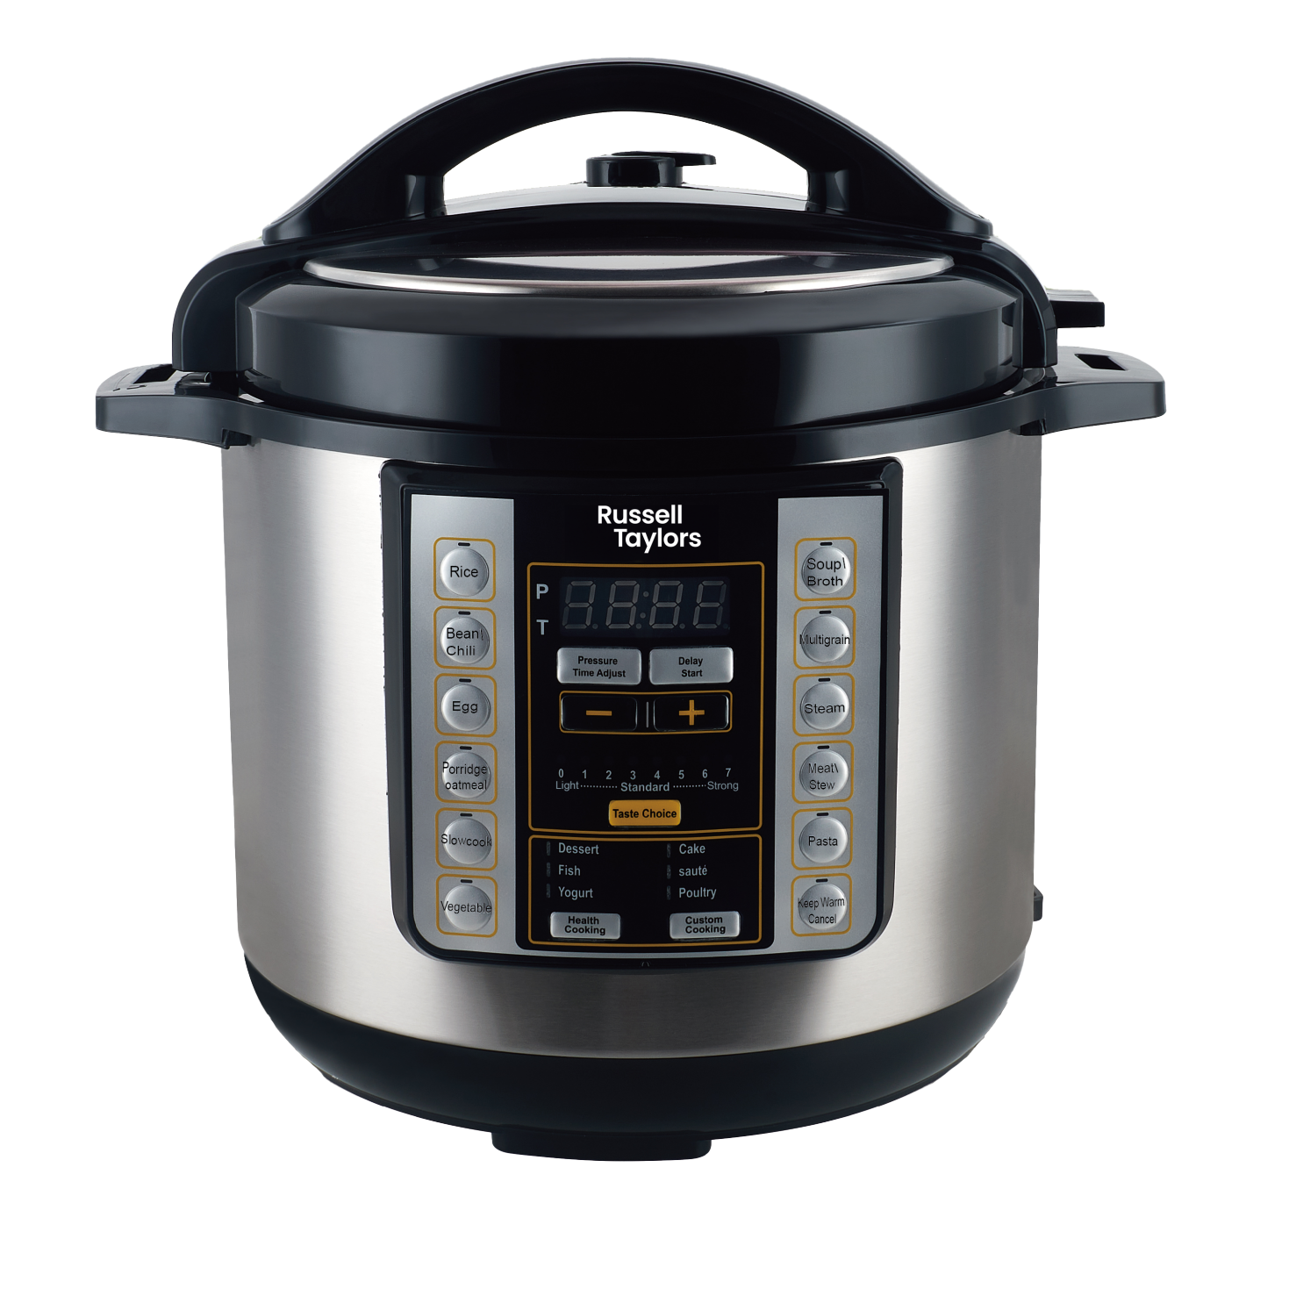

**PC6**

**IMPORTANT SAFEGUARDS**

* Before the first use, check the device specifications and the power supply in your home. This appliance is intended for household use only. Commercial usage will result in void of warranty.
* Do not use the product with a damaged cord or plug.
* Keep the power cord away from sharp edges and hot surfaces.
* Using accessories or replacement parts that are not recommended or sold by the manufacturer may cause damage to the appliance.
* Always unplug the appliance and let it cool down before cleaning and removing parts. Keep unplugged when not in use.
* To avoid electric shock and fire, do not immerse the appliance in water or other liquids. If that occurs, immediately unplug it and contact service center for inspection.
* Place the pressure cooker on a stable, horizontal and level surface. Position it far from flammable materials including curtains, walls, and fabric upholstered furniture.
* Do not place the pressure cooker near heat-emitting devices such as heaters, cooktops or electric burners.
* Make sure that there is enough space around. The pressure cooker should stand more than 15 cm away from such flammable objects as furniture, curtains etc.
* This appliance should **NOT** be used by persons with reduced physical, sensory or mental capabilities or lack of experience.
* The surface is liable to get hot during use.
* Don’t move the appliance containing hot food or liquid or when the appliance is connected to electricity network.
* Don't leave water or products in the pressure cookerfor a long time.
* Pour water into the inner pot only. Don't pour water into the pressure cooker body.
* While cooking, avoid using sharp utensils not to damage the inner pot surface. You may use also wooden, plastic or silicone utensils.
* If any unusual sounds, odor or any other disruption happens, switch the pressure cooker off. Make sure that there are no any objects or liquids between the inner pot and heating plate
* Do not cover the steam relief valve and the lid while the pressure cooker is operating. It may cause a malfunction.
* Do not let the pressure cooker work with an empty pot.
* While you are cooking, the lid and outer surface of the pressure cooker get hot. Handle or move the pressure cooker with care. The accessible surfaces may become hot when the appliance is in operation.
* When you open the pressure cooker lid, wait while steam goes out and after that you may get closer.

**ATTENTION:**

* **The central part of the pressure cooker lid becomes extremely hot while cooking and may cause burns. Always use the lid handle to operate with the lid!**
* **Beware of the hot steam that comes out of the steam release opening. Keep hands and face away from the pressure cooker when you open it to avoid being burnt by hot steam**
* Don't cover or block steam release opening, steam relief valve and float valve.
* Don't press on float valve while the pressure cooker is working.
* Before pressure cooking make sure the inner pot contains water or broth. Pressure cooking needs liquid for producing steam & pressure.

**INTRODUCTION**

**The product has the following characteristics:**

1. **Multi-Functions, Convenient to use**
   1. This Multifunction Electric Pressure Cooker offers high variety of options for professional cooking according to customers’ tastes. Only press your favorite taste key to enter the automatic cooking progress. When finished, there will be a beep tone sound and the pressure cooker will change into keep warm mode.
   2. 24 hours timer preset function : After setting the time, the pressure cooker will start to countdown, when countdown comes to 0, it will start the cooking program.
2. **Fast Cooking, Saving Energy.**

It saves about 20% of your time and more than 25% of power when cooking main courses and about 40% of time and more than 50% of power when cooking soups and porridges.

1. **Retain Nutrition, Better Taste**

Adopts pure hermetic cooking technology, this pressure cooker keeps nutrition and primary taste cooking.

1. **Safety**

**Safety lock**: The cover cannot be closed if it is not fit well and cannot be opened if it is high pressure inside.

**Pressure control safety device**: The pressure cooker will be switched off automatically when it reaches pre-setting pressure temperature for stable pressure containing.

**Pressure regulation**: If the temperature and pressure reach their max level, float valve will release pressure via the vent valve.

**Anti-blocked safety device**: Helps to avoid block of outlet of air by food.

**Pressure-relief safety device**: It will prevent explosion when mentioned above safety devices cannot help any more.

**Overheat safety device**: When temperature reaches limitation, the fuse will release.

**Temperature regulation**: In case of wrong operation if the inner pot is empty or temperature is not according to program, regulator will connect or disconnect power.

**INSTRUCTIONS FOR USE**

**Before Cooking:**

**1.** To remove lid, grasp handle, turn clockwise and lift. (See figure A, B)

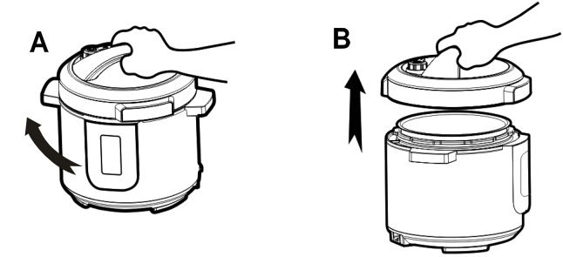

**2.** Remove the cooking pot from the pressure cooker and add food and liquids as the recipe directs.

**Quantities to be observed:**

The total volume of food and liquid must not exceed 80% of the capacity of the cooking pot (figure C).For foods such as dried vegetables and beans, or rice and grains, the total volume must not exceed 60% capacity (figure D). Always use at least 1/2 cup liquid when pressure cooking. The total volume of food and liquid must not less than 20% of the capacity of the cooking pot (figure E).

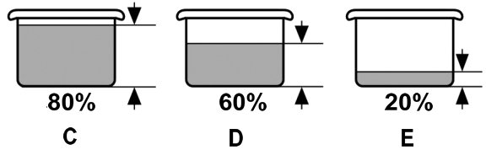

**3.** Close the cover. Ensure the lid sits on the pot correctly. Then rotate the handle of cover anticlockwise until it “clicks” (figure F-1, F-2)

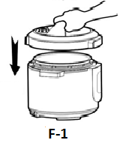 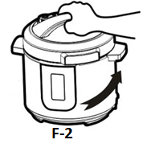

1. Position the float valve and turn it to the sealed position, then check if the float valve is fallen down(figure G-1, G-2).

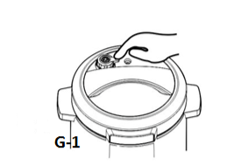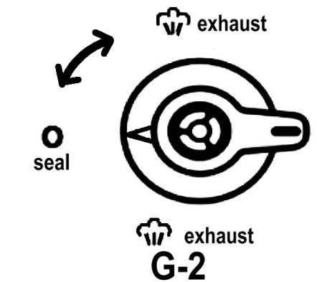

**Start Cooking:**

* + - 1. Plug the power cord into the pressure cooker and then into the wall outlet. The LED display will show the sign of”**0000“.**
      2. Press the **Desired Cooking** **Menu** e.g. Rice**.** Cooking time will be displayed.
      3. Press your **Taste Choice**. You can select **Light** food taste(cook shorter time), **Standard**(Default hold pressure time) or **Strong** taste(longer hold pressure time.
      4. To add cooking time, you must select an item (rice/Steam/etc.) from the menu first, then press " **Pressure Time Adjust**" then the "**+**" or "**-**" button to adjust time manually.
      5. Cooker will start automatically in 5 seconds after you stop operate the cooker.
      6. To delay the start of cooking/operation. Press "**Delay Start**," then use the "**+**" & "**-**" keys to adjust the delay time with increments of 30 minutes, up to 24 hours.

(*Example: If you wish to program the pressure cooker to automatically turn on*

*in 3-hours, press the DELAY START button, then press the* ***+***

*button 5 more times until the LED screen displays 03:00).*)

* + - 1. When pressure cooking cycle is finished, the unit will automatically switch to the **keep warm** function. Place float valve into release position and wait until the internal pressure has been completely released before opening the cover.

**A table guide is shown below indicating the “keep pressure time” for different cooking options.**

|  |  |  |  |  |  |
| --- | --- | --- | --- | --- | --- |
| **MENU** | **default time**  **(mins**) | **Taste Choice(mins**) | | | **Pressure Time Adjust(mins**) |
| **Light** | **Standard** | **Strong** |
| **Rice** | 12 | 8 | 12 | 15 | 1-20 |
| **Bean\Chili** | 40 | 40 | 40 | 1 hour | 1 min-1 hour |
| **Egg** | 10 | 8 | 10 | 15 | 1-20 |
| **Porridge\oatmeal** | 15 | 10 | 15 | 20 | 1-25 |
| **Slowcook** | 2 hours | 1 hour | 2 hours | 3 hours | 1-4hours |
| **Vegetable** | 10 | 8 | 10 | 15 | 1-20 |
| **Soup\Broth** | 30 | 20 | 30 | 40 | 1-50 |
| **Multigrain** | 20 | 15 | 20 | 30 | 1-35 |
| **Steam** | 15 | 10 | 15 | 20 | 1-40 |
| **Meat\Stew** | 35 | 8 | 10 | 15 | 1min-1hour |
| **Pasta** | 10 | 8 | 10 | 15 | 1-30 |
| **Dessert** | 20 | 15 | 20 | 30 | 1-40 |
| **Fish** | 10 | 8 | 10 | 15 | 1-20 |
| **Yogurt** | 3 hours | 3 hours | 3 hours | 6 hours | 1-6hours |
| **Cake** | 35 | 25 | 35 | 45 | 1min-1hour |
| **sauté** | 40 | 30 | 40 | 50 | 1min-1hour |
| **Poultry** | 20 | 15 | 20 | 30 | 1-40 |

**TIP: When you sauté food, you can operate cooker with open lid.**

**CLEANING**

**1.** Unplug the power cord before cleaning.

**2.** Clean the outer body with a soft cloth. Do not immerse the outer body in water or pour water onto it.

**3.** Rinse the underside of the lid including the sealing ring, pressure limit valve, anti-block cover, air escape and float valve with warm water. Allow to dry completely.

**4.** Clean the area under the upper ring with a soft cloth. Do not use chemical cleaners.

**5.** The cooking pot is dishwasher-safe. To hand-clean the cooking pot, use a soft cloth or sponge and wipe. Be careful not to damage the inside coating. Never use harsh chemicals or scouring pads.

**6.** To clean sealing ring, hold the knob on the sealing ring supporting cover and pull the sealing ring up. After cleaning, put the sealing ring supporting cover back.

**TROUBLESHOOTING**

|  |  |  |
| --- | --- | --- |
| **Symptom** | **Possible Reasons** | **Solutions** |
| Lid does not lock | The ring is not properly installed | Reinstall the ring |
| The float is seized by the push rod | Push the rod with hands |
| Cannot open the lid after air exhaust | The float is still up | Press the float down |
| Air escapes from the rim of  the lid | No sealing ring was installed | Install the sealing ring |
| Food residue on sealing ring | Clean sealing ring |
| Sealing ring worn out | Replace the sealing ring |
| Lid not locked properly | Rotate lid fully |
| Air escapes from the float  valve | Food stuck on the sealing ring of  the float valve | Clean the sealing ring |
| The sealing ring on the float wore  out | Replace the sealing ring |
| The float will not rise | The pressure limit valve is not  placed properly | Place the device to Pressure |
| Not enough food and water | Check recipe for proper quantity |
| Air escaping from the rim of the  lid and the pressure limit valve | Call our Consumer Service Center |
| Display E1 | Sensor control  broken circuit | Call our Consumer Service Center |
| Display E2 | Sensor control  short circuit | Wait till it cool down |
| Display E3 | Inner pot temperature overheat | Call our Consumer Service Center |
| Display E4 | Pressure switch error | Call our Consumer Service Center |

